Intrusion Detection System (IDS) Lab

Ryan Coon

CYB-525

Dr. Emmett Ward

December 4, 2024

Part 1:

Screenshots:

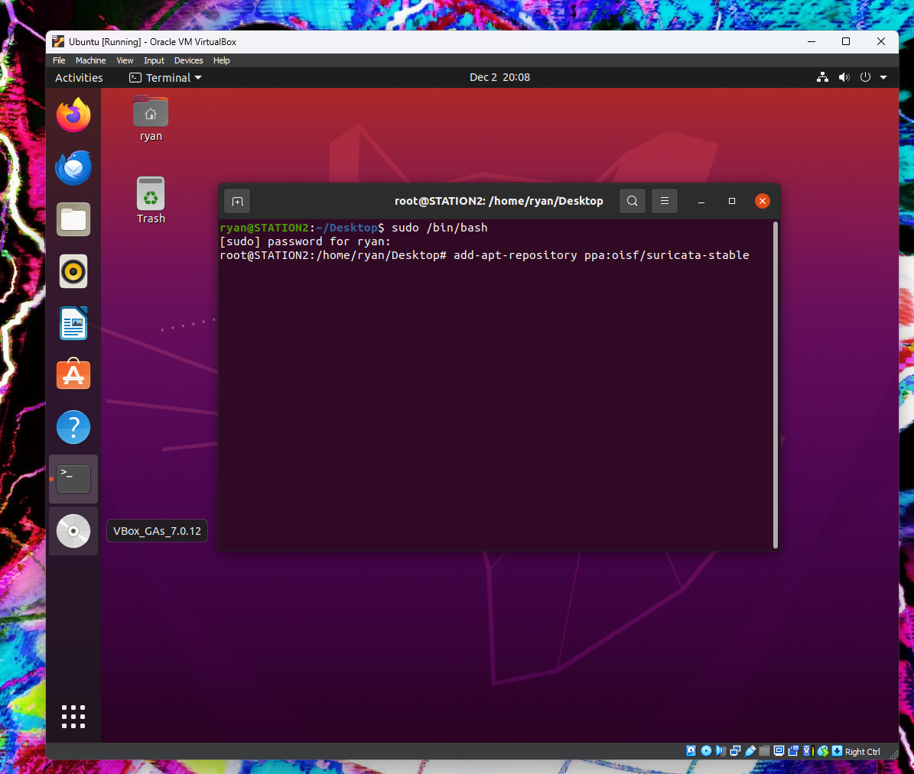

In the terminal with root permissions, we type in this command to add the Suricata software.

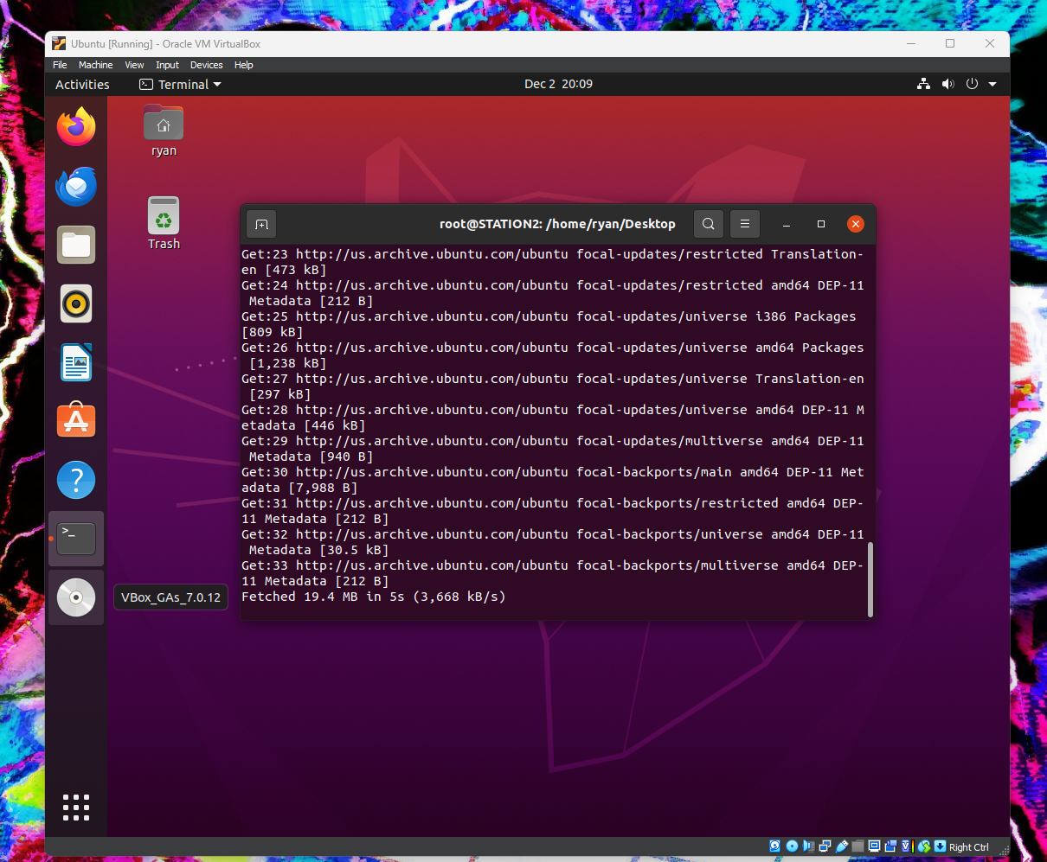

Suricata is now installing its package repository

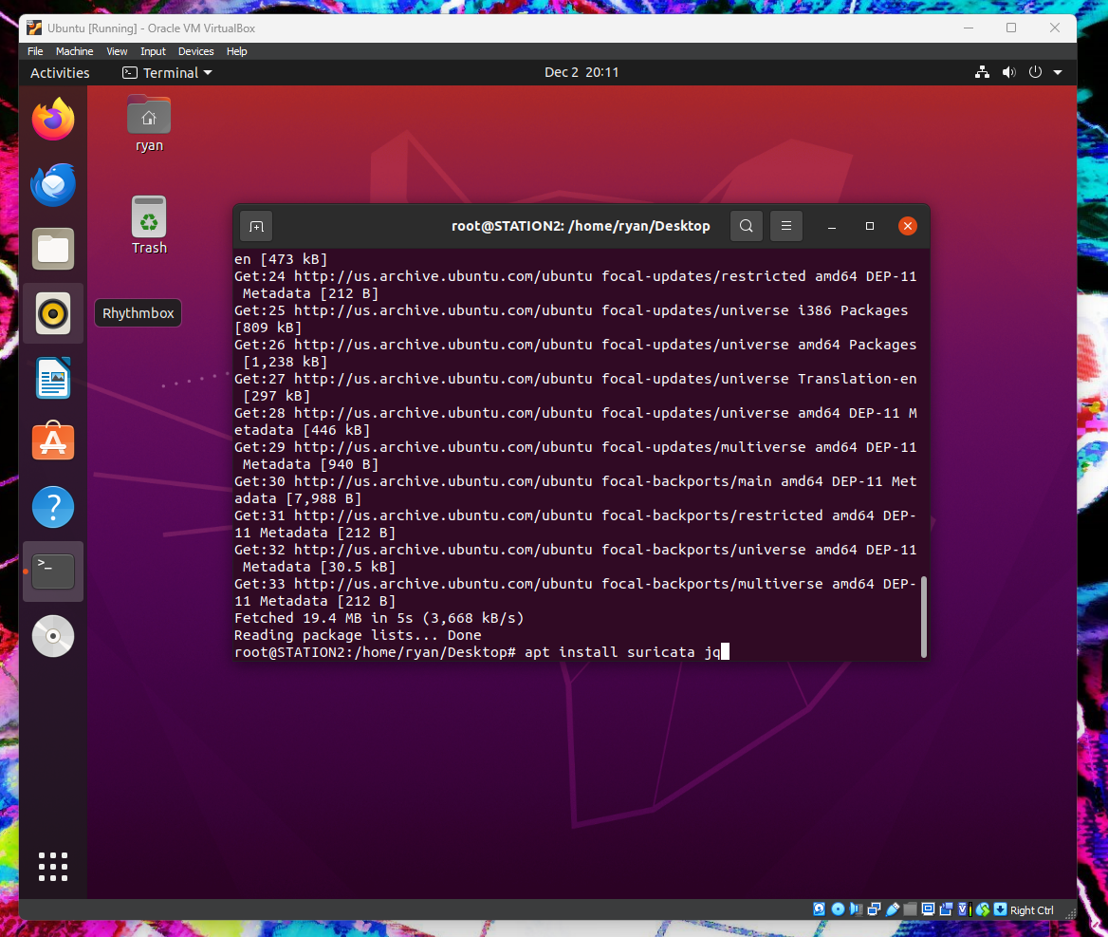

Running this command to install Suricata and JQ

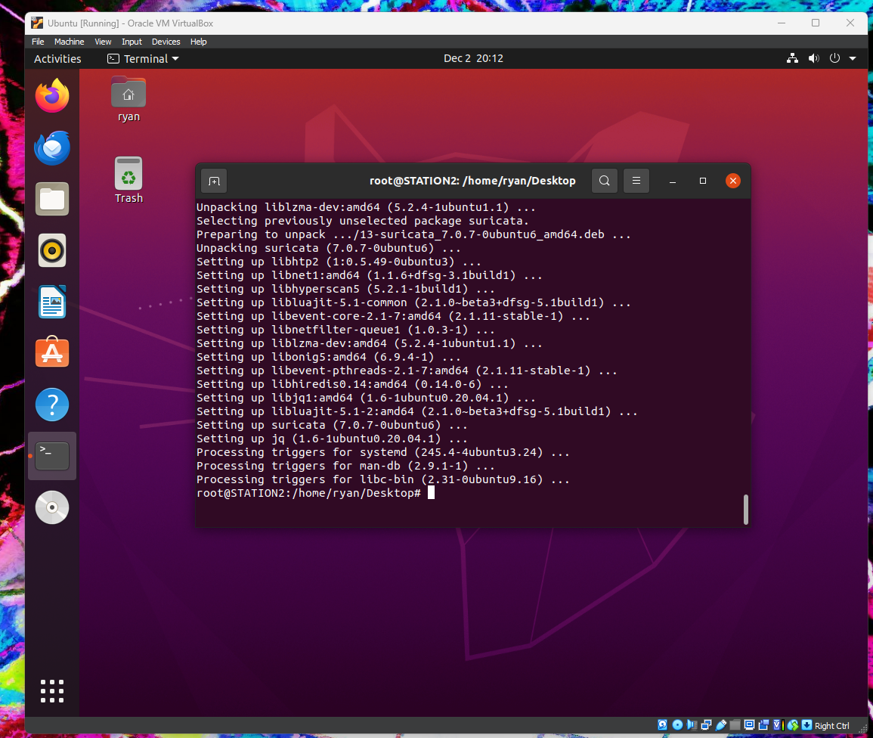

Suricata and JQ finished installing.

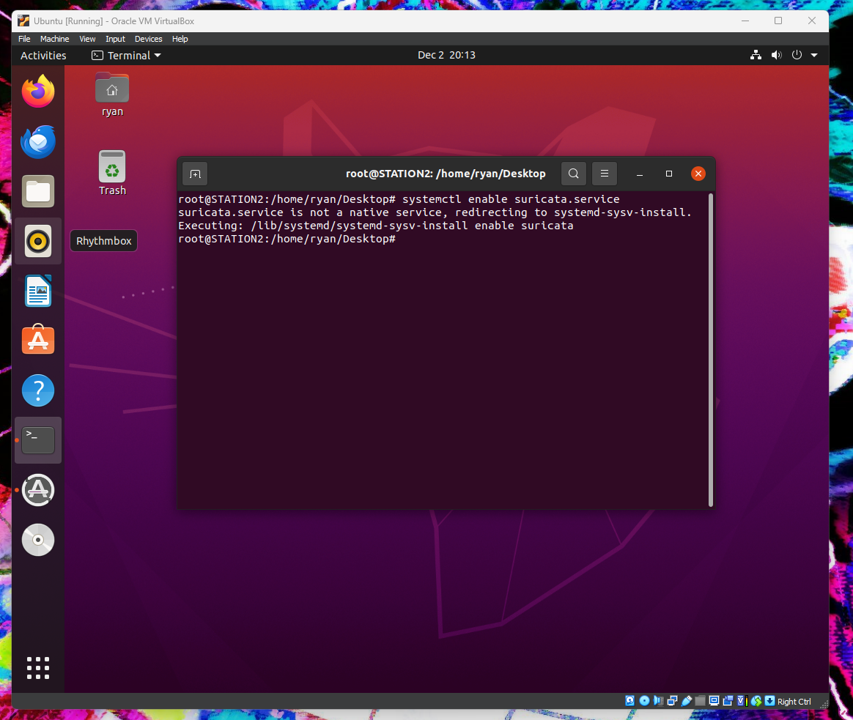

Testing to see if Suricata will start.

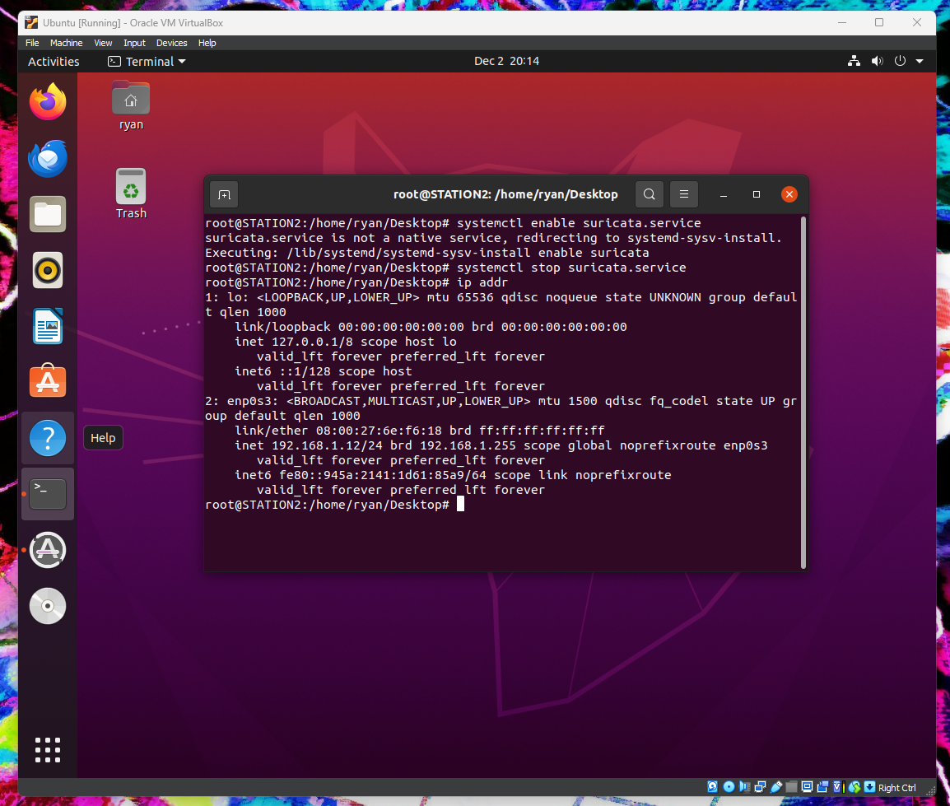

Ran command ip addr to see our ip address and network device name.

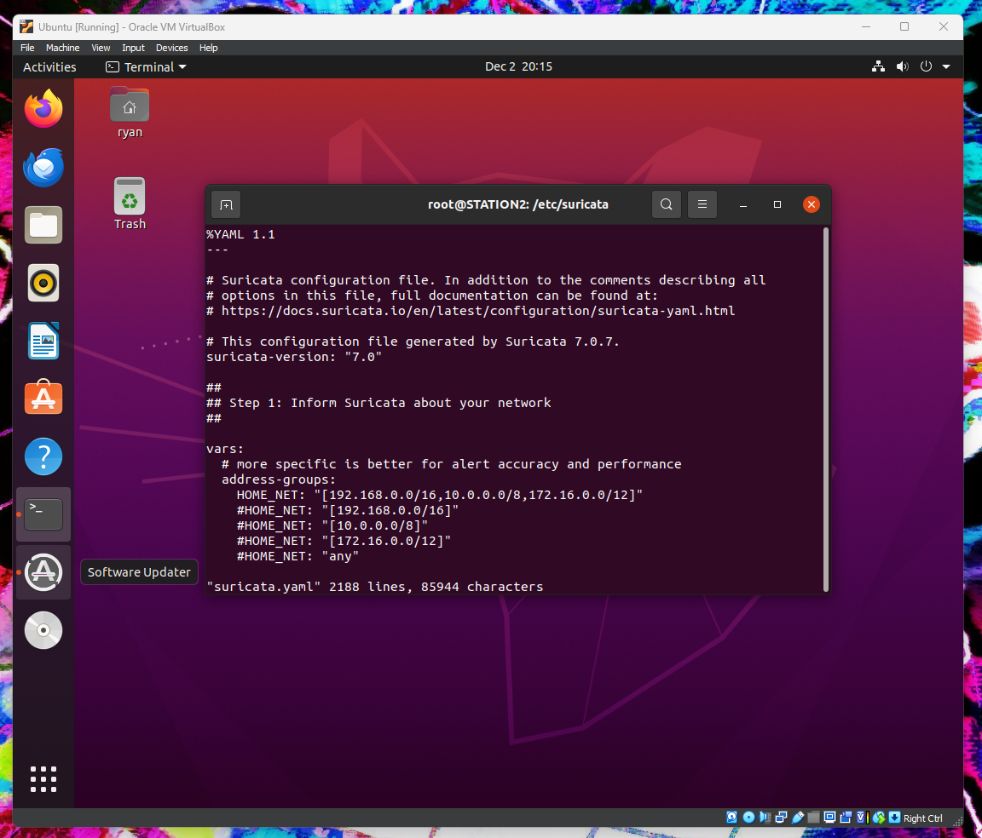

Here we navigated into the suricata folder in order to find and open the suricata.yaml file in order to edit it.

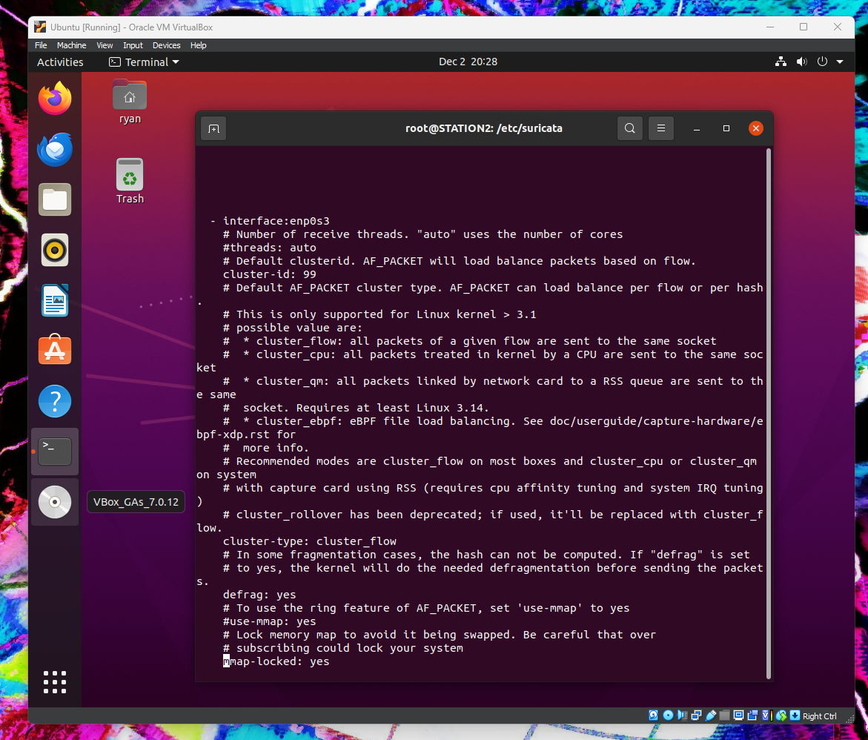

Making the necessary changes to the suricata.yaml file

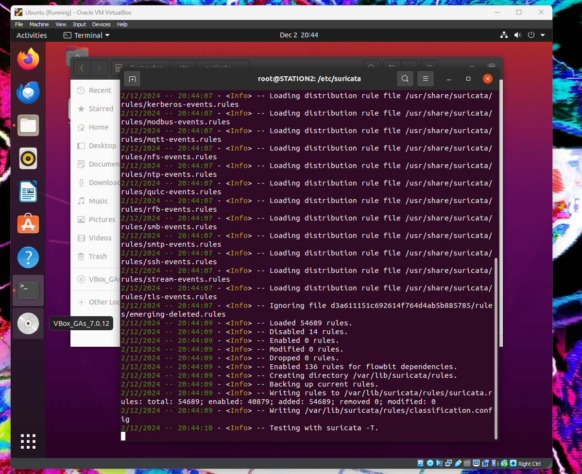

Running suricata update

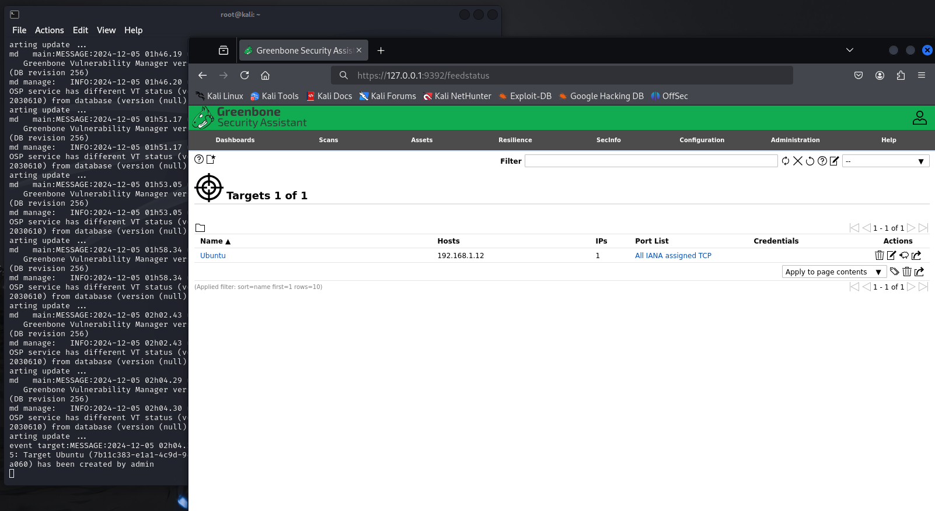

Set up the target Ubuntu in Greenbone from the Kali server.

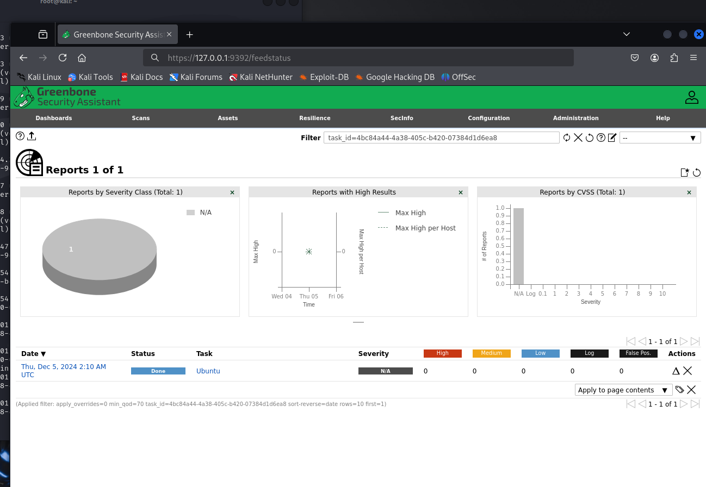

Running the scan in Greenbone.

Part 2:

**Summarize the issues encountered, lessons learned, and successes in a bullet point format.**

* I learned how to install and configure Suricata on an Ubuntu VM.
* During the installation I did not face any issues.
* I learned that Suricata is a free and open-source network intrusion detection system and intrusion prevention system. It is capable of inspecting network traffic in real-time using rule-based detection methods and can alert network administrators when it detects suspicious or malicious activity on the network.
* The only issue I encountered was with performing the scan in Greenbone, my problem was that I did not have any scan configs configured, so I could not run a scan. I had to run again the tail -f gvmd.log command, as well as the greenbone-feed-sync commands. I had the system running for about a week and configs still did not finish downloading.

**Describe the screenshots provided.**

All screenshot descriptions are captioned under each screenshot.

**Describe the methodologies used in network forensics. Include packet capture, deep packet inspection, and the analysis of protocols.**

Network forensics is the process of collecting, analyzing, and preserving network traffic data in order to investigate security incidents, identify potential threats, and respond to security breaches. There are several methodologies used in network forensics, including packet capture, deep packet inspection, and the analysis of protocols.

Packet capture is the process of capturing and storing network traffic data in real-time or near-real-time. This can be done using a variety of tools, such as Wireshark, tcpdump, or Suricata, and allows investigators to reconstruct network traffic and analyze it for evidence of malicious activity. Packet capture can be performed at various points in the network, such as at the perimeter firewall or on individual hosts, to gather information about the source and nature of an attack.

Deep packet inspection (DPI) involves analyzing the content of network packets beyond just the headers. This allows investigators to identify specific types of traffic, such as encrypted traffic or traffic associated with particular applications or services. DPI can be used to detect and analyze network-based attacks, such as malware downloads, command-and-control communication, or data exfiltration.

The analysis of protocols involves examining the behavior of network protocols, such as TCP, UDP, HTTP, DNS, and others, to identify anomalies or signs of suspicious activity. This can involve examining network traffic for specific protocol-level indicators, such as unusual port usage or non-standard protocol behavior, as well as analyzing patterns of traffic to identify potential attacks or malicious activity

**Analyze and decipher network traffic, identify anomalous or malicious activity, and provide a summary of the effects on the system.**

Analyzing and deciphering network traffic is a critical component of cybersecurity, enabling organizations to identify anomalous or malicious activities that could compromise their systems. Here’s a structured approach to understanding this process and its implications:

Network Traffic Analysis

Network traffic analysis involves monitoring and inspecting data packets as they travel across a network. By establishing a baseline of normal network behavior, analysts can detect deviations that may indicate security threats. Different protocols (e.g., HTTP, FTP, DNS) are analyzed to ensure they are functioning correctly and securely.

Identifying Anomalous or Malicious Activity

Tools utilize machine learning and behavioral modeling to spot unusual traffic patterns, such as unexpected spikes in data transfer or connections from unfamiliar IP addresses. Intrusion Detection Systems (IDS) monitor network traffic for known threats and alert security teams to potential breaches.

Common Indicators of Malicious Activity

Some typical signs of malicious activity include:

Unusual Traffic Volume - A sudden increase in outbound traffic may indicate data exfiltration.

Unauthorized Access Attempts - Repeated failed login attempts from a single IP address can signal a brute-force attack.

Communication with Known Malicious Ips - Traffic directed towards blacklisted IP addresses is a strong indicator of compromise.

4. Effects on the System

Unauthorized access can lead to sensitive data being stolen or compromised. Malicious activities, such as Distributed Denial of Service (DDoS) attacks, can disrupt normal operations, leading to downtime and loss of productivity. Organizations may incur costs related to incident response, recovery, and potential legal liabilities.

**Describe how analytic methodologies, both qualitative and quantitative, could leverage the IDS to predict and communicate network anomalies.**

Qualitative Methodologies

Qualitative analysis focuses on understanding the context and characteristics of network behavior. It involves subjective assessment and interpretation of data, which can be beneficial by allowing behavioral analysis, risk assessment, and incident reporting.

Analysts can observe and interpret user behavior and network interactions to identify anomalies. For instance, if a user typically accesses certain files during business hours but suddenly accesses sensitive data at odd hours, this could indicate a potential security threat. Qualitative methods can help in assessing the potential impact of identified anomalies. By categorizing risks based on their severity and likelihood, organizations can prioritize their response strategies effectively. Qualitative insights can enhance communication about anomalies. Detailed reports that describe the nature of the anomaly, potential impacts, and recommended actions can be generated, facilitating better decision-making.

Quantitative Methodologies

Quantitative analysis relies on numerical data and statistical methods to identify patterns and predict anomalies. By applying statistical techniques, such as regression analysis or time-series analysis, organizations can establish a baseline of normal network behavior. Deviations from this baseline can be flagged as potential anomalies. Quantitative methods enable the use of machine learning models that can learn from historical data. These models can identify patterns of normal behavior and detect deviations, thus predicting potential intrusions before they occur. Quantitative analysis allows for the measurement of various performance metrics, such as false positive rates and detection accuracy. This data can be used to refine IDS algorithms and improve their predictive capabilities.

Combining Both Methodologies

Integrating qualitative and quantitative methodologies can enhance the overall effectiveness of IDS in predicting and communicating network anomalies. Combining both approaches provides a comprehensive view of network behavior, allowing for more accurate anomaly detection and risk assessment. The qualitative insights can contextualize the quantitative data, making it easier for stakeholders to understand the significance of detected anomalies and the necessary response actions. Feedback from qualitative assessments can inform the refinement of quantitative models, leading to improved detection rates and reduced false positives over time.

References:

Ahmed Tamer Assy, Mostafa, Y., Ahmed Abd El-khaleq, & Mashaly, M. (2023). Anomaly-Based Intrusion Detection System using One-Dimensional Convolutional Neural Network. *Procedia Computer Science*, *220*, 78–85. https://doi.org/10.1016/j.procs.2023.03.013

CISCO. (2023). *What Is Network Traffic Analysis - NTA*. Cisco. https://www.cisco.com/c/en/us/products/security/what-is-network-traffic-analysis.html

dcurwin. (2024, October 23). *How to investigate anomaly detection alerts - Microsoft Defender for Cloud Apps*. Learn.microsoft.com. https://learn.microsoft.com/en-us/defender-cloud-apps/investigate-anomaly-alerts

Haider, W., Hu, J., Slay, J., Turnbull, B. P., & Xie, Y. (2017). Generating realistic intrusion detection system dataset based on fuzzy qualitative modeling. *Journal of Network and Computer Applications*, *87*, 185–192. https://doi.org/10.1016/j.jnca.2017.03.018

Lippmann, R., Haines, J., & Zissman, M. (n.d.). *An Overview of Issues in Testing Intrusion Detection Systems*. https://nvlpubs.nist.gov/nistpubs/Legacy/IR/nistir7007.pdf

Manpreet. (2024, May 3). *Mastering Quantitative Risk Assessment: A step-by-step guide*. Scrut Automation. https://www.scrut.io/post/mastering-quantitative-risk-assessment-a-step-by-step-guide

Srėbaliūtė, A. (2024, June 4). *How to analyze network traffic: a step-by-step guide*. Nordlayer.com. https://nordlayer.com/blog/how-to-analyze-network-traffic/